**Website Global Brief:**

**Heading Font Family:** Open Sans

**Body / Content Font family:** Poppins

Top Header:



Comment:

1. Use Font Awesome icon for Social media and others

2. Social media icon must have link with a hover color. Such as – fb link, twitter link, etc.

3. Please use mailto to link for email and tell link for phone number with a hover color

**Main Header:**



1. Menu font family **Poppins**

2. Menu font size: 16px

3. Menu font color: #222222

4. Menu hover color: #2c76e2

5. Service menu should be drop down option.

6. Here is the menu item text:

Home, About, Doctors, Services, Blog, Contact

**Service menu drop down text:**

Cardiology, Heart Care, Dental Care, Kidney Disease

Main Banner Section:



**Comment:**

1. Heading font size: 45px & color: #222222

2. Content font size: 18px & color: #878787

3. Button background color: # 1160D4

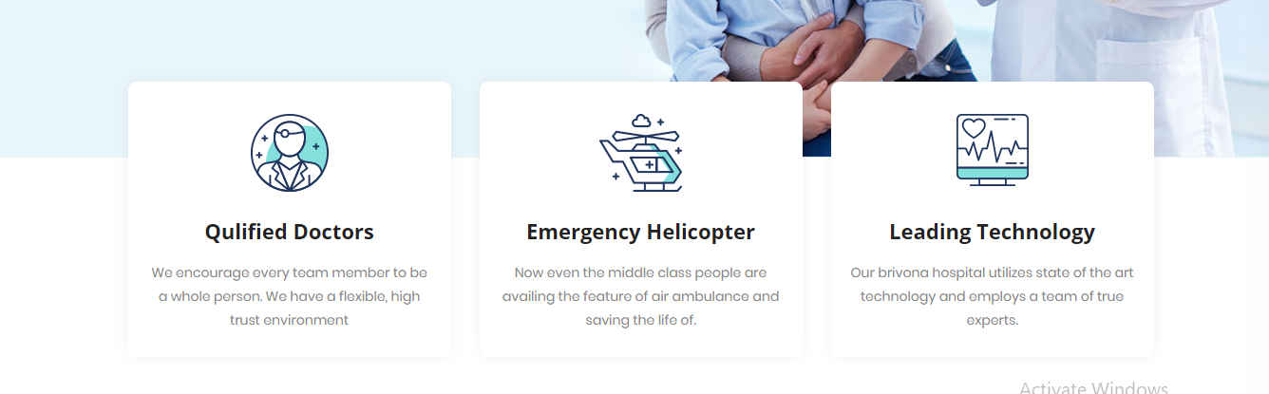

1. Please use image as icon.

2. Heading font size: 22px & color: #222222

3. Content font size: 14px & color: #878787



Comment:

1. Heading font size: 32px & color: #222222

2. Content font size: 16px & color: #878787

3. Please use font awesome icon

4. Background colors of first icon #0BC1BB, Second icon #2C76E2 & Third icon #FE94C4

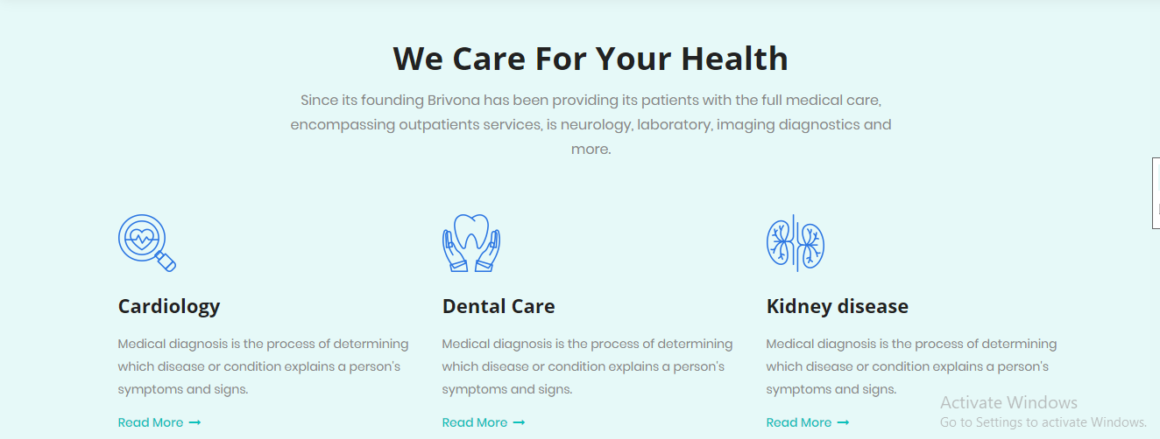

**Comment:**

1. Section Background color: #E6F9F8

2. Heading font size: 32px & color: #222222

3. Content font size: 14px & color: #878787

4. Read more Button color: #0bc1bb& Hover color #1160d4

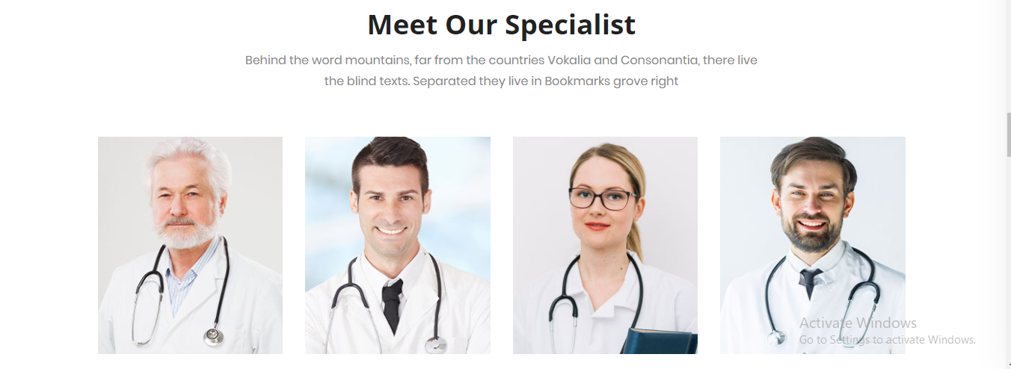

Comment:

1. Use Owlcarousel Slide for This section.

2. Heading font size: 37px & color: #222222

3. Content font size: 16px & color: #878787

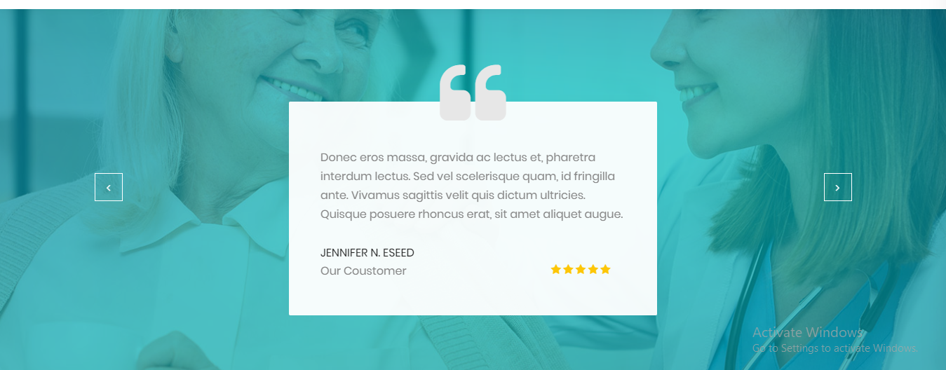

1. Use Owlcarousel Slide for This section.

2. Content font size: 16px & color: #878787